Name:______________
Math 1 Quadratics Test Review
A carnival game involves striking a lever that forces a weight up a tube. If the weight reaches 20 feet to ring the bell, the contestant wins a prize. The weight travels with an initial velocity is 32 feet per second.
- Write the rule that models the height of the weight as a function of time.

- How long will it take to reach the maximum height?

- What is the maximum height?

- Will a prize be won?

Miriam has 40 meters of fencing to build a pen for her dog.
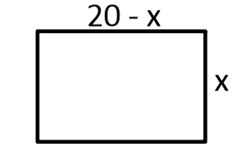
- Use the figure at the right to write an equation of the area A of the pen.

- What value of x will result in the greatest area?

- What is the greatest possible are of the pen?

Given: y = x² – x – 2
8) Fill in the table: 9) Find the max/min 10) Graph 11) State the solutions.
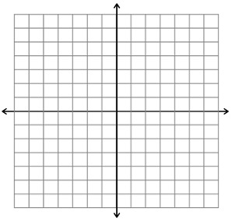

x | y
-2
-1
0
1
2
3
Factor the following.
12) 13x + 26y 13) 2x² – 10x 14) y² + 7y + 12 15) 2x² + 10x – 12

Solve the following.
16) 3x(x + 7) = 0 17) (3x + 4)(x – 5) = 0 18) m² – m = 12 19) 11x² – x = 3

