Name:___________________________
Math 1 Graphing Systems of Equations

Graph the two equations on the given coordinate plane. Then write out the point where they meet.
(To graph the equations must be solved for y)

1) y = -3 and y = 2x – 1 2) x = 1 and 2x + y = 4 3) 3y = -x – 3 and x – 3y = -3

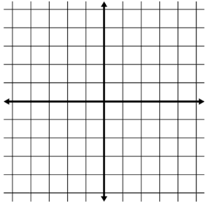

4) 3x + y = -3 and 3x + y = 3 5) y – x = -1 and x + y = 3 6) y = x + 2 and x – y = -2

7) x – y = 3 and x – 2y = 3 8) x + 2y = 3 and 3x – y = -5 9) y = 2x – 3 and 2x – 2y = 2

