Name:____________________________

**Unit 3 Systems Review**

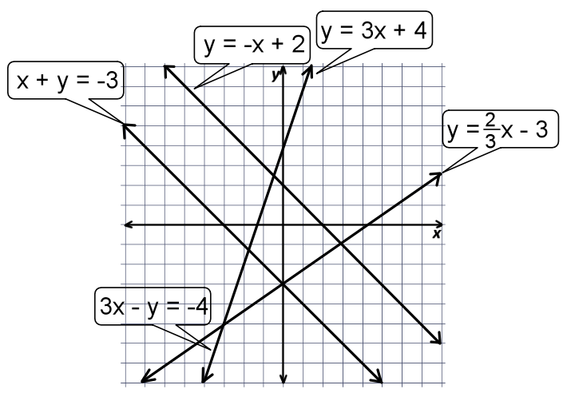**Determine how many solutions exist for each system of equations. One Solution, No Solution, or Many Solutions.**

1) x + y = - 3 and 3x – y = -4

2) y = -x + 2 and x + y = -3

3) y = 3x + 4 and y = x – 3



4) 3x – y = -4 and y = 3x + 4



**Graph the following systems of equations and Name the solution.**

5) y = -x + 2 6) y = x



y = -2x + 4 x + y = 3

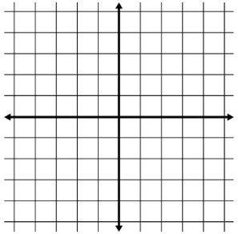

**Solve the following systems of equations.**

7) y = 5x - 8 8) y = 2x + 6 9) y = 2x – 2

4x + 3y = 33 2x – y = 2 x – y = -2

10) 3x + y = 12 11) 2x – y = -1 12) 5x + 2y = -3

x + y = -2 3x – 2y = 1 3x + 3y = 9

**(Questions 13 – 16) The owner of a local water park is trying to figure out the best way to make the most total profit each month. Currently it cost him $2000 each month to run the park, and he is charging $10 per person. He decides he can cut some cost and bring his monthly cost down to $1500. If he does this he can drop the price to $8 per person.**

13) Write a rule for the first situation.

14) Write a rule for the second situation.

15) After how many customers will he break even in the first situation?

16) After how many customers will he break even in the second situation?

17) How many customers will have to visit the park for both situations to produce the same amount of income?

18) Under what circumstances would he want to choose the first situation?

19) Under what circumstances would he want to choose the second situation?

20) Two submarines began dives in the same vertical position to meet at a designated point. If one submarine was on a course approximated by the equation **x + 4y = -14** and the other was on a course approximated by the equation **x + 3y = -8**, at what location would they meet?

21) The Feel Better Spa has two specials for new members. They can receive 3 facials and 5 manicures for $114 or 3 facials and 2 manicures for $78. What are the prices for facials and manicures?

22) The perimeter of a rectangle is 20 inches. The width is two less than the length. Find the length and the width of the rectangle.

23) The sum of two numbers is 70. The smaller number is 10 more than 2 times the larger. Find the two numbers.

**Graph the following systems of inequalities. Check them in your calculator.**

24) y ≥ x – 1 25) 2y + x < 4 26) y + 4 < x

2 x + y < 3 3x – y > 1 -2y – 4 < 3x



**Graph and tell if each coordinate is a solution the system of inequalities given.**

y ≥ 2x + 2

x + y ≤ -1



27) (-3, 1)

28) (0, -3)

29) (-2, -2)

30) (3, -1)

31) (-1, 0)

Robbie and Jack are driving to the beach for spring break. Robbie starts 45 minutes behind Jack and is driving 55 mph. Jack is driving his grandmothers broken down car and can only go 35 mph.

32) Write an equation for Robbie.

31) Write an equation for Jack.

32) How long will it take for Jack to catch up to Robbie.