Name:______________________________

Date:______________________Pd:______

**Quadratic Functions**

1) John, Jim, and Jill made a catapult for a science project. The catapult they constructed released a tennis ball 3 feet from the ground. After the tennis ball was fired, it hit the ground after about 6 seconds. The flight of the ball can be modeled by the function rule *h* = -16*t*2 + 95.5*t* + 3, where *h* is the height of the ball in feet after *t* number of seconds.

a. Write out the coordinate for the starting point (_____,_____), and the point where it lands (_____,_____).

b. After how many seconds does the ball reach its maximum height? 

c. What is the maximum height? (plug *t* into the rule and solve for *h*)

d. What is the height of the ball after only 1 second? (*t* = 1) After 5 seconds? (t = 5)

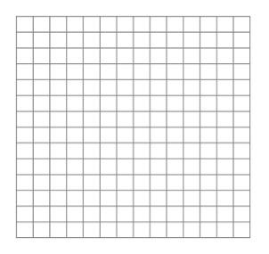 e. Make a sketch of the flight path of the tennis ball on the coordinate plane using the 5 points found above.

2) Sam takes his math book to the top of a twelve story building and looks down at the ground that is 160 feet below. He throws it with an initial velocity of 48 feet per second. He was then arrested by the math police.

a. Write a rule that models the height of the book as a function of the time in seconds it is in the air.

b. Fill in the table to find out how many seconds it takes Sam’s book to hit the ground?

|  |  |  |  |  |  |  |  |
| --- | --- | --- | --- | --- | --- | --- | --- |
| t | 0 | 1 | 2 | 3 | 4 | 5 | 6 |
| h |  |  |  |  |  |  |  |

c. After how many seconds does the math book reach its maximum height?

d. What is the maximum height?

e. What is the height of the book after 4 seconds

|  |  |  |  |
| --- | --- | --- | --- |
| **Rule** | **Table** | **Max/Min** | **Graph** |
| **y = x2 + 2x + 1** | |  |  |  |  |  | | --- | --- | --- | --- | --- | | -3 | -2 | -1 | 0 | 1 | |  |  |  |  |  | |  | 14 by 14 axes |
| ***y* = -*x*2 + 2*x* + 1** | |  |  |  |  |  | | --- | --- | --- | --- | --- | | 0 | 1 | 2 | 3 | 4 | |  |  |  |  |  | |  | 14 by 14 axes |
| **y=2x2 + 8x** | |  |  |  |  |  | | --- | --- | --- | --- | --- | | -4 | -3 | -2 | -1 | 0 | |  |  |  |  |  | |  | 14 by 14 axes |
| **y=-x2 – 2** | |  |  |  |  |  | | --- | --- | --- | --- | --- | | -4 | -2 | 0 | 2 | 4 | |  |  |  |  |  | |  | 14 by 14 axes |