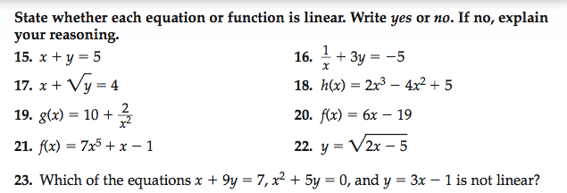

**From here down ODDS ONLY**

