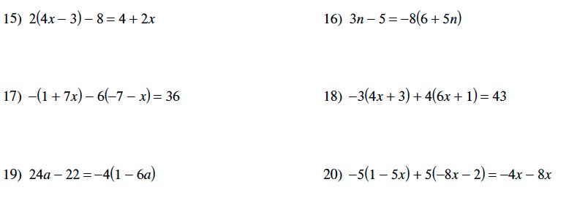
Test Review

Part 1 Solving Equations

Part 2 Fractional Equations
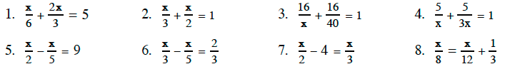

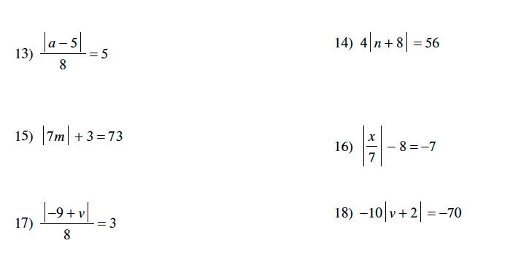
Part 3 Absolute Value Equations

Part 4 Literal Equations

