**Name:________________________**

**Slope/Rate of Change Review**

**; ; ; ; **

**(table) (2 pts) (graph)**

**Find the slope of each linear function. CIRCLE FINAL ANSWER**

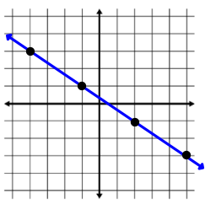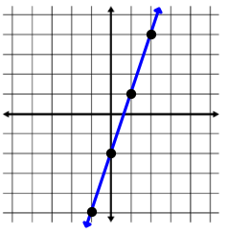1) y = 4x – 5 2) y = 8 - x 3) 4)

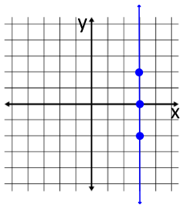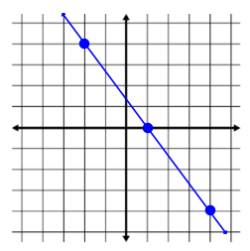

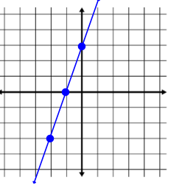5) 6) 7)

|  |  |  |  |  |
| --- | --- | --- | --- | --- |
| x | -50 | -40 | -30 | -20 |
| y | 1300 | 1050 | 800 | 550 |

|  |  |
| --- | --- |
| x | y |
| -5 | -3 |
| 0 | -2 |
| 5 | -1 |
| 10 | 0 |

|  |  |
| --- | --- |
| x | y |
| 2 | 3 |
| 5 | 0 |
| 8 | -3 |
| 11 | -6 |

8) 9) 10)

**Find the slope of the line going through the two given points.**

11) (3, 8) (2, 5) 12) (5, -3) (4, 2) 13) (9, -3) (4, -3) 14) (-2, 3) (5, -1)

15) (7, 1) (0, 8) 16) (-3, -2) (-5, -4) 17) (4, -3) (4, 6) 18) (1, 1) (3, 4)

19) A rocket is 1 mile above the earth 30 seconds after it is launched. After 2.5 minutes the rocket is 5 miles above the earth. What is the rockets rate of change in miles per second? What about miles per minute?

20) After 30 baseball games, A-Rod had 25 hits. If after 100 games he had 80 hits, what is his average hits per baseball game?

21) A scuba diver is 30 feet below the surface of the water 10 seconds after he entered the water and 100 feet below the surface after 40 seconds. What is the divers rate of change?

22) A plane left Chicago at 8:00 A.M. At 1:00 P.M., the plane landed in Los Angeles, which is 1500 miles away. What was the average rate of speed of the plane for the trip?