**Name:____________________________**

**Writing Equations of Lines**

**Write the equation of a line given the slope and y-intercept. (**y = mx + b)

1) slope = -2, y-intercept = 7 2) slope = 4 y-intercept = -1 3) slope = , y-intercept = -2

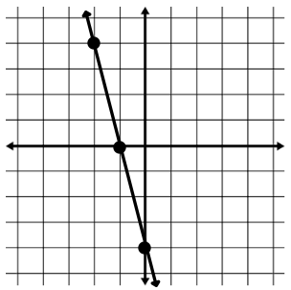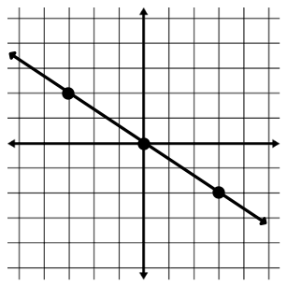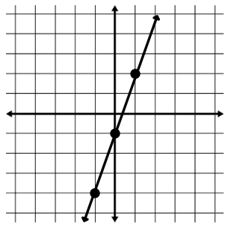4) 5) 6)

**Write the equation of a line given a table.**

|  |  |
| --- | --- |
| x | y |
| -2 | -11 |
| 0 | -5 |
| 2 | 1 |
| 4 | 7 |

|  |  |
| --- | --- |
| x | y |
| 5 | 3 |
| 10 | 8 |
| 15 | 13 |
| 20 | 18 |

|  |  |
| --- | --- |
| x | y |
| 5 | -6 |
| 15 | -26 |
| 25 | -46 |
| 35 | -66 |

7) 8) 9)

Slope = _____ y-int = ______ Slope = _____ y-int = ______ Slope = _____ y-int = ______

y = ____________ y = ____________ y = ____________

**Write the equation of a line given a slope and a point.**

10) m = 5; (2, 4) 11) m = ; (4, -1) 13) m = -1; (-5, 3)

**Write the equation of a line given two points.**

11) contains (-1, 7) and (3, -9) 12) contains (3, -4) and (-5, -12)

13) contains (-5, 8) and (-3, 0) 14) contains (3, -5) and (6, -5)

14) x-int = 6, y-int = -6 15) x-int = -1, y-int = -5

**Write an equation given the following.** y – y1 = m(x – x1)

16) contains (3, 2) and is || to y = x + 5 17) contains (-2, 5) and is || to y = -4x + 2

m = _______ m = _______

|| m = ______ ||m = _______

⊥m = ______ ⊥m = ______

y = _____________ y = ______________

18) contains (-3, 4) and is || to 3y = 2x - 3 19) contains (-1, -2) and is || to 3x – y = 5

m = _______ m = _______

|| m = ______ ||m = _______

⊥m = ______ ⊥m = ______

y = _____________ y = ______________

20) contains (-2, -2) and is ⊥ to y = x + 9 21) contains (-6, 5) and is ⊥ to x – y = 5

m = _______ m = _______

|| m = ______ ||m = _______

⊥m = ______ ⊥m = ______

y = _____________ y = ______________

22) contains (2, 4) and is ⊥ to x – 6y = 2 23) contains (-1, -7) and is ⊥ to 3x + 12y = -6

m = _______ m = _______

|| m = ______ ||m = _______

⊥m = ______ ⊥m = ______

y = _____________ y = ______________

24) contains (1, -5) and is ⊥ to x = 6 25) contains (-6, 5) and is|| to 2y = -4

m = _______ m = _______

|| m = ______ ||m = _______

⊥m = ______ ⊥m = ______

y = _____________ x = ______________